CHAPTER 12

Why does the shortest day not coincide with the latest sunrise?

Introduction

In the old days when we all had paper diaries, the times of sunrise and sunset were printed – usually for Sundays. I looked at the longest summer day in Cambridge and found it was 16 hours and 46 minutes. The longest winter night was 16 hours and 18 minutes. It puzzled me that the longest night wasn’t the same as the longest day. I thought I understood physics. What is going on? It wasn’t easy to find these things out in the days before the internet, so I asked a friend who said “maybe it’s because the sun isn’t a point of light – it takes some time for the disc of the sun to move below the horizon”. Of course, how obvious!

For millennia we’ve been fascinated with the details of time. Look at the thousands that make their way to Stonehenge (Fig. 1) for the summer solstice. But even the ancients must have noticed that there is a ‘bug’ in the way time works if you rely on the Sun. This chapter picks all this apart.

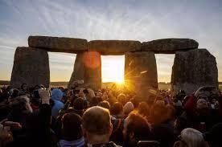

Fig.1. Stonehenge OUP: NOT SURE WHERE THIS IMAGE IS FROM

- Why does the shortest day not coincide with the latest sunrise?

The simple qualitative answer to this is that, because of the elliptical orbit of the Earth, and the angle its axis makes to the orbit, the rate at which the Sun crosses the sky is not constant throughout the year. Kepler’s law says that an orbiting body sweeps out an equal area in equal time as it travels on its elliptical path. We choose twenty-four hours to be the average length of a day, but because of the Earth’s elliptical orbit, the Sun is actually only at its highest at mid-day twice per year. This also means that the timing of sunrise and sunset differ from the time shown by our watches. The story is made even more complicated when considering the latitude of the observer. If you live near the equator, then you probably won’t notice very much, but in artic regions, the timing of sunrise and sunset is hugely variable and governs people’s lives.

Figure 2 shows the effect of the faster movement of the Earth in its orbit near the winter solstice, starting at the time where watch noon and solar noon coincide (around Dec. 25th).
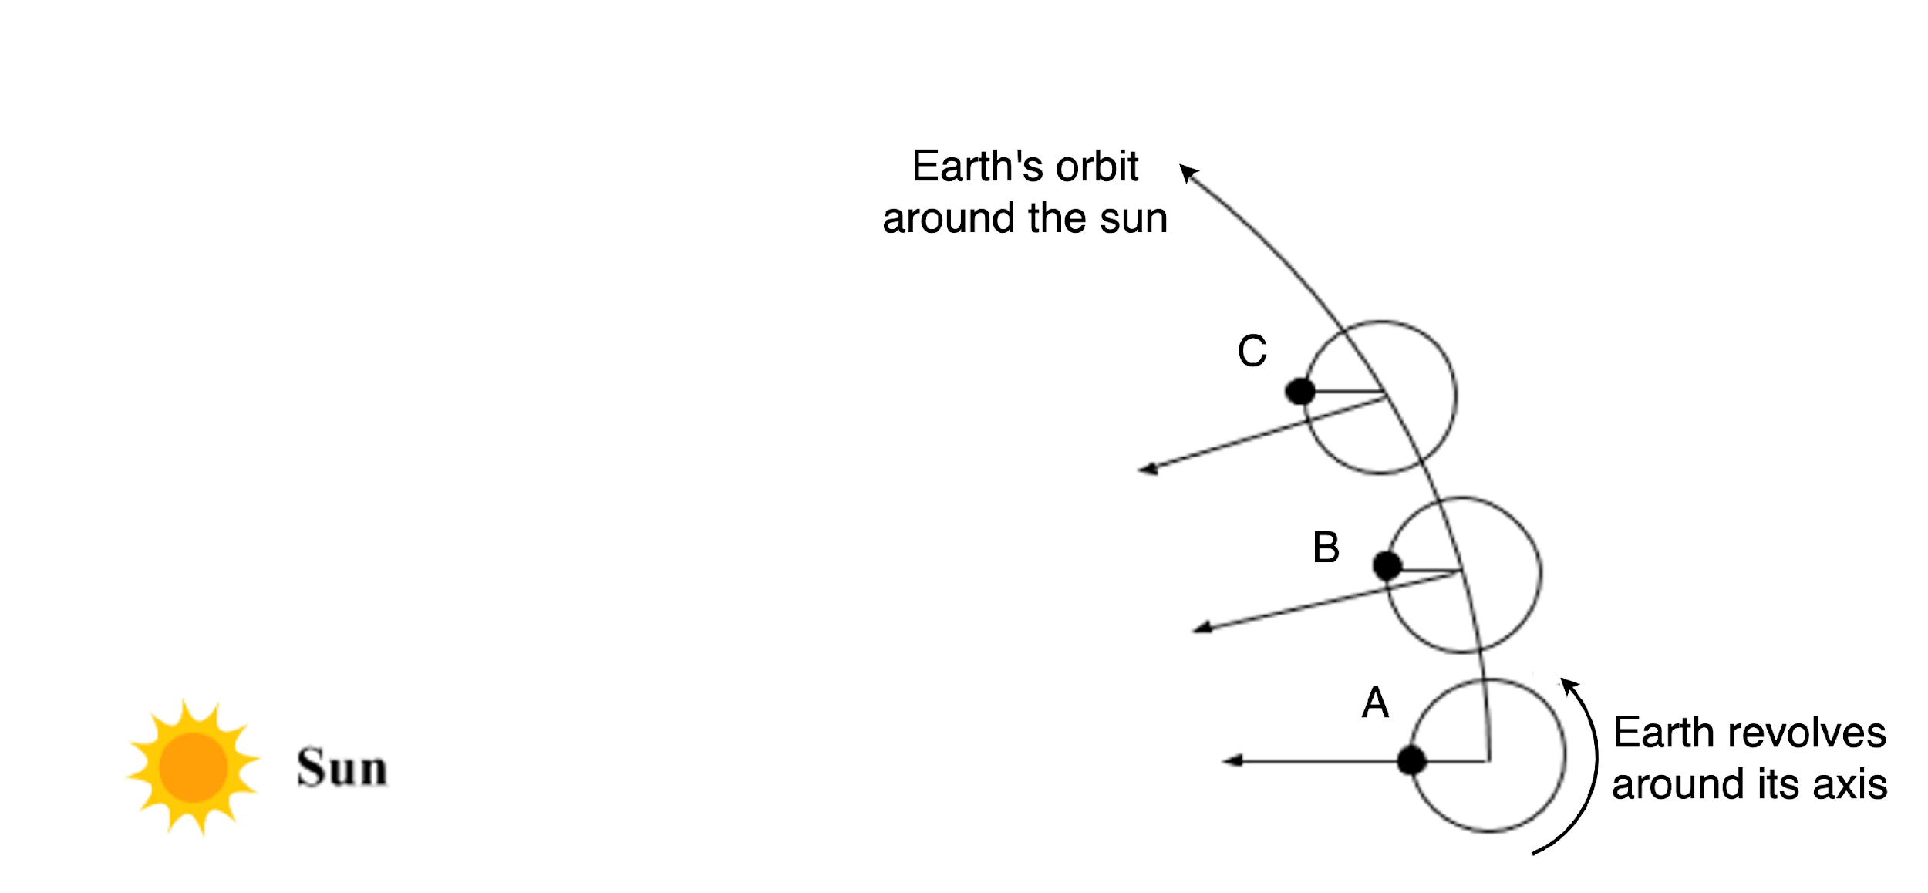

Fig. 2. The Earth at three points of its orbit A, B and C at time intervals of 23.934 hours. If the earth’s orbit around the sun were circular, then the sun would be overhead every 24 hours. On an elliptical orbit the speed of the earth varies depending on where it is in the orbit, so the timing of “solar noon” varies depending on the time of year.

The black dot in Fig. 2 is a place on the Earth where the sun at noon is directly overhead (position A). Position B is shown 23.934 hours later, when the Earth has rotated exactly 360º as measured relative to a distant star. However, the Sun is no longer overhead. We must wait a couple of minutes before it is solar noon, which gives us our 24-hour solar day. We set our watches on the apparent movement of the sun and, even if the Earth did not rotate, we would still see a day of one year in length. Therefore, we expect to have one extra day in the solar year compared with the sidereal year. On average this adds 236 seconds to the sidereal day due to the Earth’s orbit around the sun. The word “sidereal” refers to measurements made with respect to distant stars.

One second is defined such that the mean solar day is equal to twenty-four hours. We have clocks that keep time much more accurately than can be deduced from the rotation of the Earth. The effect of the moon on the Earth causes tidal friction and the Earth’s spin is slowing down, so that the day is getting longer by 2.3 millisecond per century. There are other short term changes due to major earthquakes and even climate change that alter the moment of inertia of the Earth. The apparent motion of the Sun isn’t really relevant for timekeeping any more, sadly.

The story is more complicated because the Earth moves in an elliptical orbit around the sun. Let’s suppose that the Earth is closest to the Sun in position A in Fig. This point in the orbit is known as the perihelion. The naming convention comes from the Greek, “peri” meaning “close” and “helion” meaning “sun”. Half a year later, the Earth would be at the aphelion, “apo” meaning “away from”. There are similar words for the Moon’s orbit around the Earth, “perigee” and “apogee”. The easiest way to remember which is to think of “perilously close”.

At the perihelion, the Earth is moving faster than the average speed of the orbit. This comes from Kepler’s law of motion that a body moving in an elliptical orbit sweeps out equal areas in equal time. The result is that the Earth at times B and C will be further round the orbit than it would be based on the mean speed in orbit. We must wait longer for noon than expected and an accurate watch will seem to be fast compared with the solar time, for which noon is defined as the time of maximum height of the Sun. How confusing! Surely a sundial is a good way of telling the time? Maybe not.

The effect on sunrise and sunset around the winter solstice (shortest day) is shown diagrammatically in Fig. 3. Here the x axis shows the time of year around 21 December (the winter solstice). On that date the day is at its shortest and the night is at its longest. One might expect also that the sun would begin to rise earlier. This is not the case. For the city of Brighton, show in the diagram, the Sun rises later and later until about 30 December. Likewise, the sunset reaches its earliest time around 12 December. This asymmetry is al caused by the combination of elliptical orbit of the Earth and the inclination of its axis.

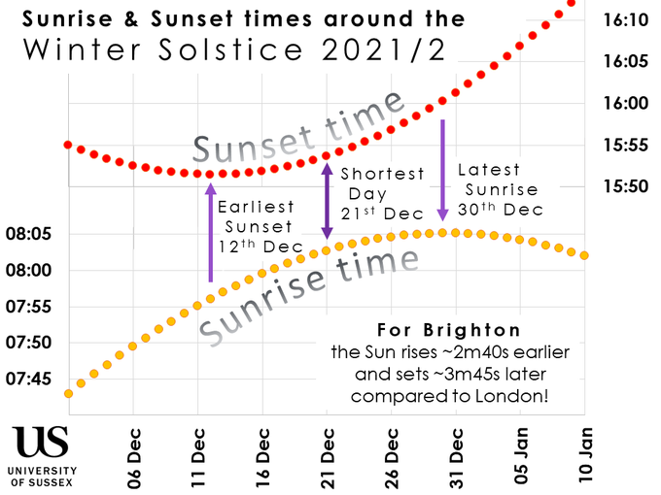

Fig. 3. Sunrise, noon and sunset around the winter solstice.

OUP: Image from University of Sussex: https://x.com/PhysicsAtSussex/status/1471522760161644551

There is also the distinction between “civil twilight”, “nautical twilight” and “astronomical twilight”. You and I might say that the sun has set when it begins to get dark and cricket umpires might have yet another opinion. But an astronomer will need to wait a few more hours until they get out their telescope. Even the simplest definition of sunset needs to take into account the diameter of the disc of the sun. In Brighton, this alone means that the longest day in June is half an hour longer than the longest night in December.

2. The Equation of Time
To obtain realistic numbers, we need to derive the actual time interval between a watch and solar time. This is called the ‘equation of time’. Solar time defines noon to be when the Sun is directly overhead and splits the rest of that particular day into twenty-four equal hours. It can be measured with a sundial with a gnomon (the part of the sundial that casts a shadow) aligned parallel to the axis of the Earth and a circular dial divided into twenty-four equal segments. (They can be equal as the variation in the speed of the Sun amounts to a maximum of 14 seconds a day from the mean, and sundials are not this accurate). We split the apparent speed of the Sun in the sky, which, in turn, splits the solar, or sundial, time, into a number of components. The first component is that due to the rotation of the Earth. This is constant over many years and has a period 23 hr. 56 min. 4 sec. However, even if the Earth did not rotate with respect to the fixed stars, we would still see the Sun go round once a year. Therefore, we must add one day per year to the real period of the Earth, or 236 secs per day on average. This brings us to an average period of exactly 24 hrs for the Sun to go round the Earth as required, since the second is defined in this way. However, it is the variation of this period throughout the year that is of interest here. It is due to two effects of similar magnitude. We can use the mean time variation of 236 seconds due to the mean movement of the Earth round the Sun as starting point to find the time difference between solar and watch time during the year.

2.1. Effect of Eccentricity
The first effect is due to the fact that Earth’s orbit is an ellipse, not a circle. The difference between the maximum and minimum distance of the Earth from the Sun is 3.4% of the mean. From conservation of angular momentum, the angular velocity therefore varies by 6.8%. This means that since there are no sudden changes in velocity, and the period of the change is a year, we can approximate the angular velocity of the Sun due to orbital motion to a cosine wave of period one year. The mean is 236 secs/day and the amplitude therefore 3.4% of 236, i.e. 8 seconds/day. The maximum difference in velocity is at the perihelion, which at present is about 2nd January. (Dates are necessarily a bit variable, partly because they change by a day every leap year.)

2.2 The Effect of Inclination
The second source of variation is due to the inclination of the Earth’s axis to the plane of the ecliptic (the plane of the orbit of the Earth around the Sun).
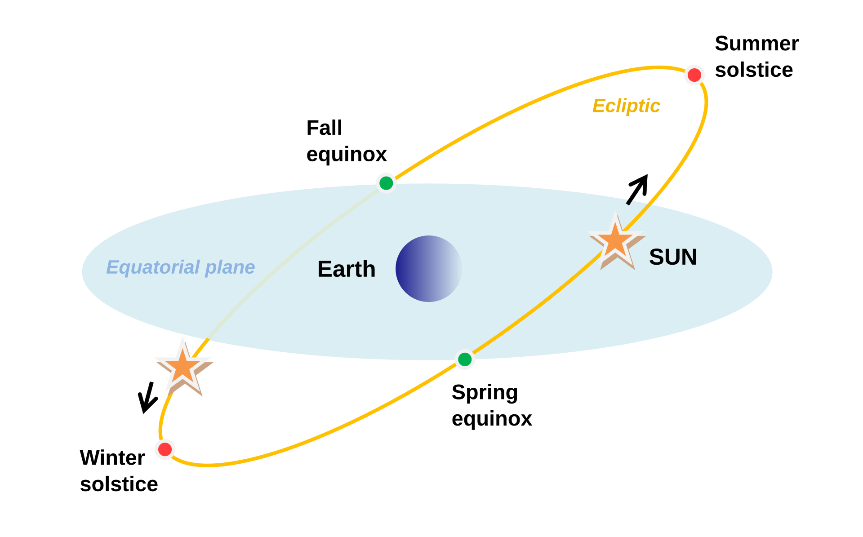

Fig. 4. An illustration of the sun orbiting the earth (an earth-centred frame of reference is convenient for this analysis). The diagram shows the summer and winter solstices (longest and shortest days) and the two equinoxes.

OUP: https://upload.wikimedia.org/wikipedia/commons/d/d0/Equinoxes-solstice-EN.svg

Figure 4 shows the Earth with its spin axis vertical so that the equatorial plane is horizontal. For ease of analysis, the Sun is shown orbiting the earth in the plane of the ecliptic, which is inclined at inclined at the angle of θ = 23.5°. From the point of view of the Earth, and ignoring the Earth’s rotation, the Sun orbits once a year. What we see on a sundial is affected by the apparent angular speed of the Sun projected onto a horizontal plane. The analysis gets a bit hairy but ultimately, we find “the equation of time”.

2.3 The equation of time
The difference between solar time (as measured by a sundial) and the real time (measured by a watch) is significant. With a bit of algebra we find that this difference can be expressed as:

The equation for E is known as the Equation of Tim and is plotted in Fig. 5.

Near the autumn equinox, the Sun is as far behind the mean position as it gets. It catches-up and coincides with the mean where E=0, about December 21st. It carries on past the mean until it reaches a maximum lead near the spring equinox. Values below the axis in Fig. 5 correspond to a watch fast compared with solar time.

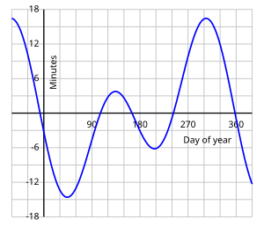

Fig. 5. The equation of time. Day 1 is 1st January. Negative is watch-fast compared with Sun. This includes both the effect of the inclination of plane of the ecliptic and the ellipticity of the Earth’s orbit.

OUP: diagram reference: https://en.wikipedia.org/wiki/Equation_of_time

3. The Length of Daylight
To find the times of sunrise and sunset as shown in Fig 3, we need to know how the length of the day varies, as it is the difference between the length of the day, and the watch time which determines sunrise and sunset times. The geometry gets a bit hairy, but here goes.

Figure 6(a) shows the Earth at the shortest day in the northern hemisphere. The arrows are the direction of sunlight. A is where the axis intersects a horizontal disc at a latitude L. N is where the normal to the ecliptic intersects the same disc. d is the distance between the two points and r is the distance AP.

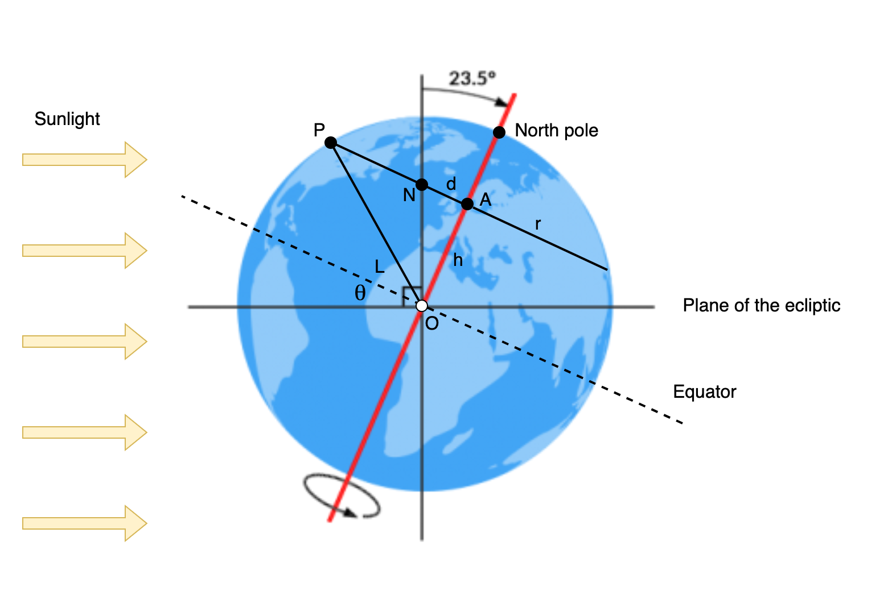 | 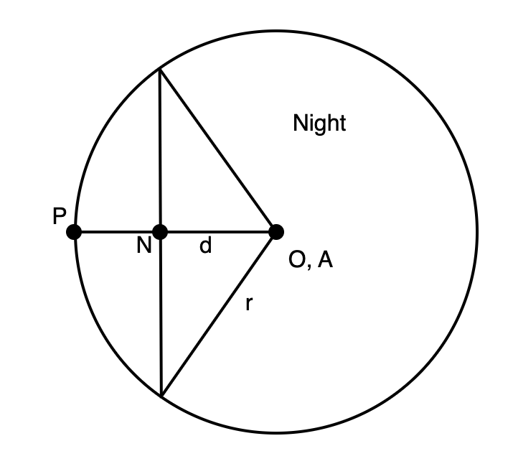
(a) | (b)

Fig. 6. Determining the time of sunrise and sunset. (a) a view of the Earth at the winter solstice (northern hemisphere). (b) a view down from the North Pole showing the section at latitude L as a circle of radius r.

OUP: background diagram of earth from here: https://earthhow.com/earth-tilt/

Figure 6(b) shows a plan of the disc at latitude L. The section to the left of N is in daylight.
From Fig. 6(a) sin(L)=h/r and tan(θ)=d/h. From Fig. 6(b) the angle subtended at A is 2 acos(d/r), noting that this gives an angle in radians.

Hence the length of daylight is:

daylength = 24 acos(–tan(L) tan(θ))/π = 7hrs 28 min 44s

This is within a minute of the mean of the shortest day (7h 42m 27s) on 21st December and the shortest night.

(7h 13m 39s on 21st June, the mean is 7h 27m 49s. Observed values of day length and sunset are taken from ‘timeanddate.com’ for Cambridge in 2012).

Published sunrise and sunset times are when the top of the Sun’s disc reaches the horizon. The Sun subtends thirty arc minutes, so this explains the half hour difference between the published shortest day and the longest night. The calculations above refer to the mean position. Again, we can represent the length of daylight as a cosine wave. Its amplitude is 3hrs 29 mins and the mean 12 hours. Then:

The shortest day = 7.48 hrs
The longest day = 24–7.48 hrs = 16.12hrs
The amplitude of variation = (16.52–7.48)/2 = 4.02hrs
Hence through the year the daylength = 12–4.52 cos[Ω(t-t_{s})]

This is in good agreement with observations, noting that it is necessary to subtract a uniform 15 mins from the observed day-length to allow for the width of the Sun.

